# Browser Compatibility test

The Browser Compatibility test could be a framework for testing web applications on various browsers or systems. Make beyond any doubt that numerous web clients work accurately. A few browser screens are in my applications.

|  |  |  |  |  |  |
| --- | --- | --- | --- | --- | --- |
| **Id** | **Title** | **Pre- Condition** | **Test Step** | **Actual Result** | **Excepted Result** |
| 6.1 | Browser Compatibility | Login in different browsers | Need to open the site on different browsers | Show site different browser correctly | Except |

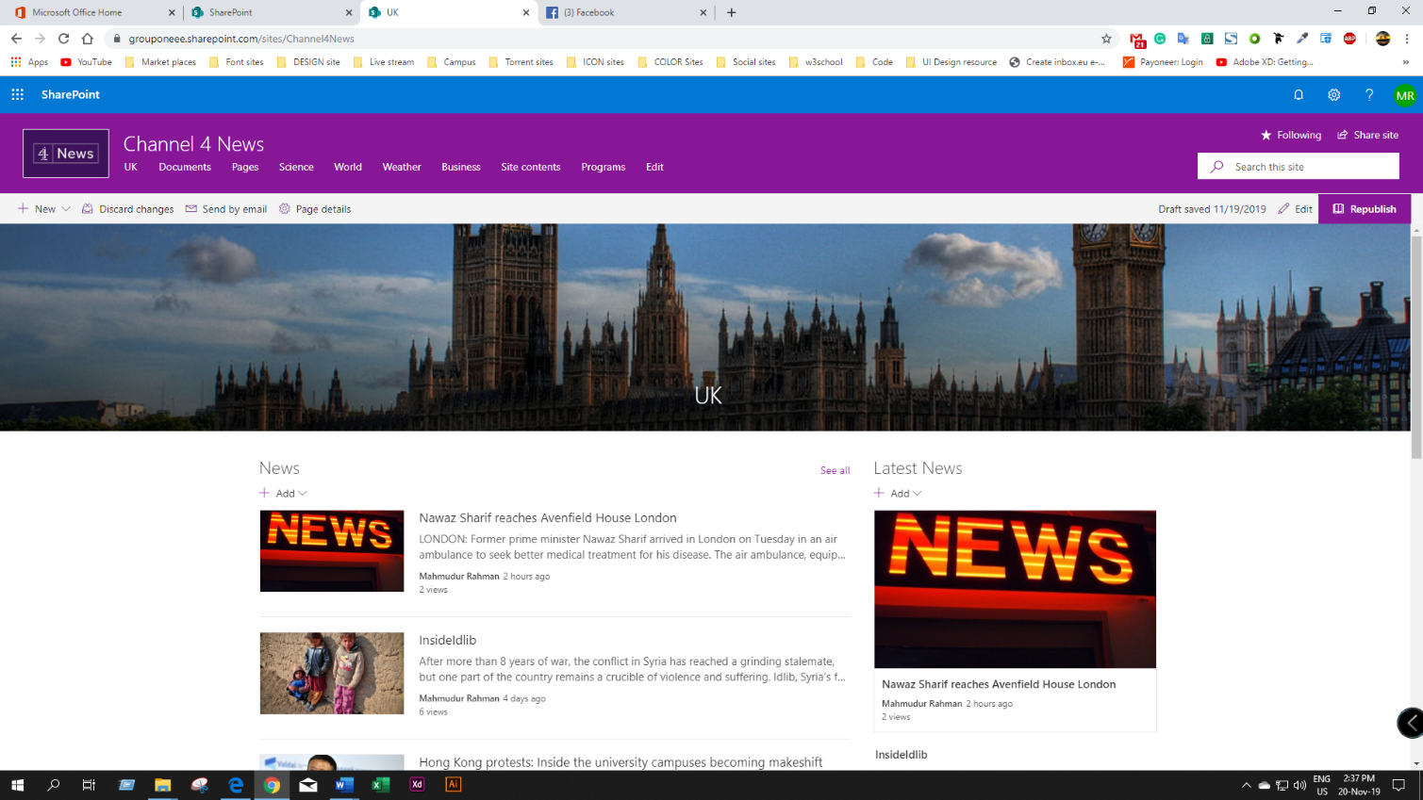

Figure 21: Chrome Browser Compatibility test

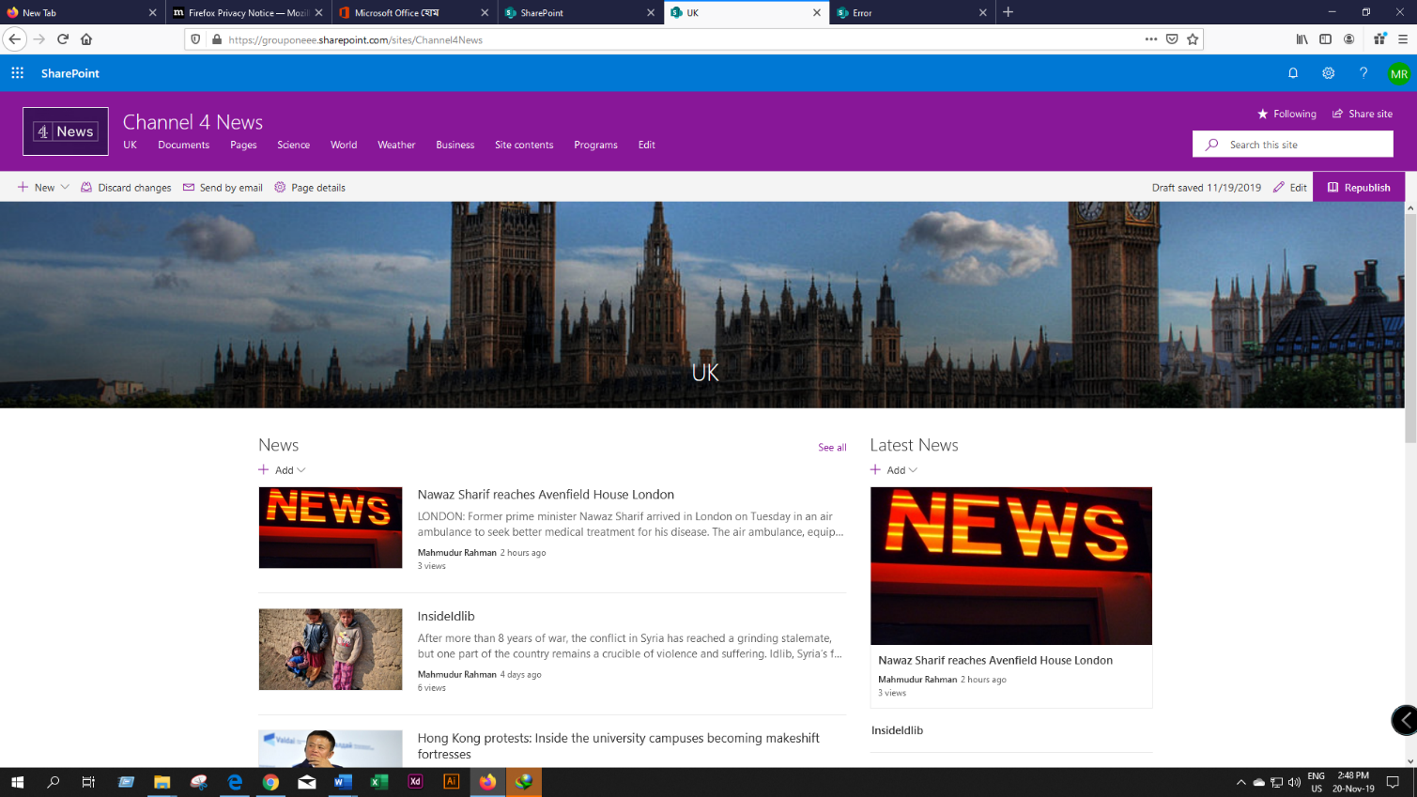

Figure 22: Mozilla Firefox Browser Compatibility test

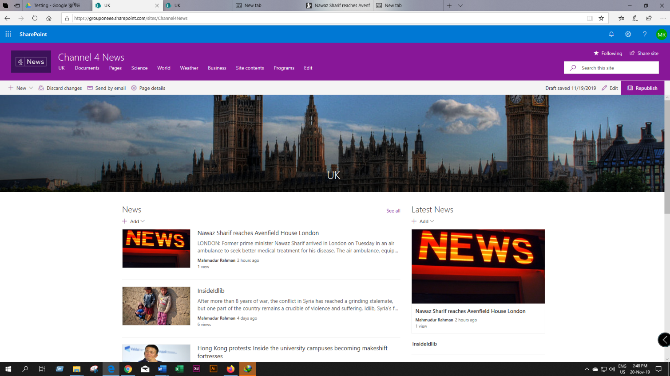

Figure 23: Internet Explorer Browser Compatibility test